**Cowrie Honeypot setup**

The objective of this documentation is to outline the steps i took in setting up a Cowrie honeypot on a Linode remote server using Kali Linux.

Steps taken:

1. **Created a Linode Instance:**

- Choose the desired specifications for my Linode, including region, distribution (select Kali Linux), and turned the virtual machine on.

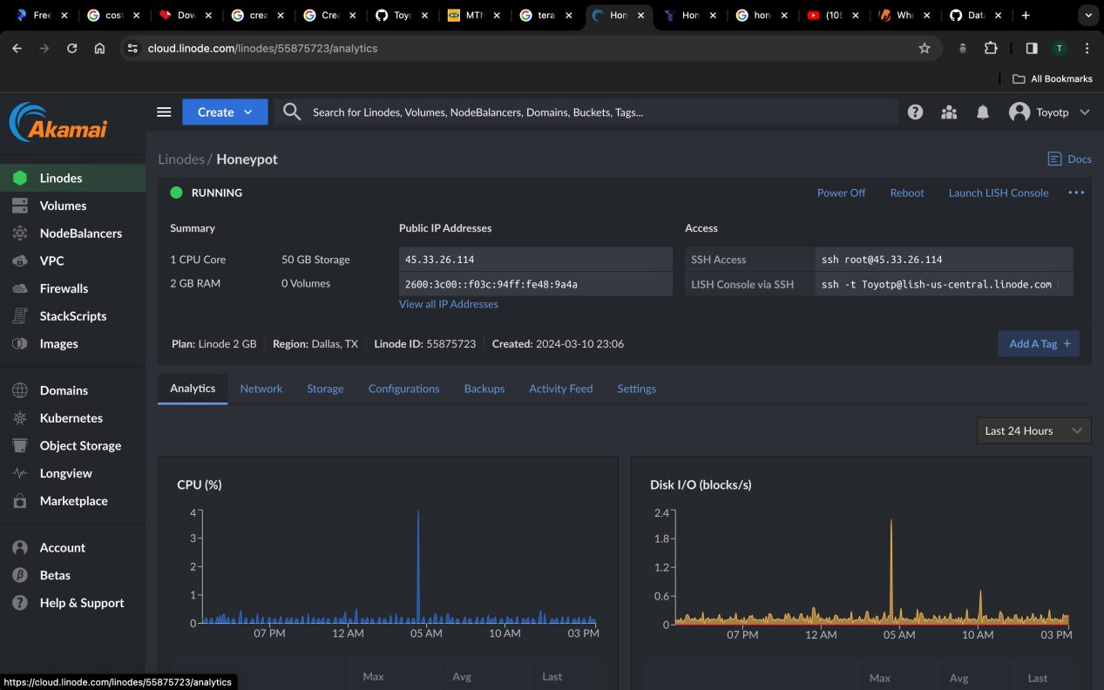

2. **Connecting to the Linode via Terminal:**

- Used SSH to connect to your Linode instance by entering the command:

( ssh [root@45.33.26.114](mailto:root@45.33.26.114) ) and entered the password i set for the Server.

1. **Configuring the Port and Changing it to "33333":**

- I navigated to the Cowrie configuration file using a text editor:

( nano cowrie/etc/cowrie.cfg.dist )

- Search for the line containing LISTEN_PORT and change its value to to a preferred high port number which was “33333”.

- Save and exit the file.

4. **Installing Cowrie:**

- Update the package index

apt update

- Install Cowrie:

apt install cowrie

5. **Creating a New User on Cowrie:**

- Create a new user account for Cowrie:

cowrie-adduser

1. **Logged back in to cowrie:**

- Using the SHH access in the root terminal followed by the port number

(ssh root@45.33.26.114 -p 33333)

- Entered the Server password

- Logged back in to cowrie using root

(su - cowrie)

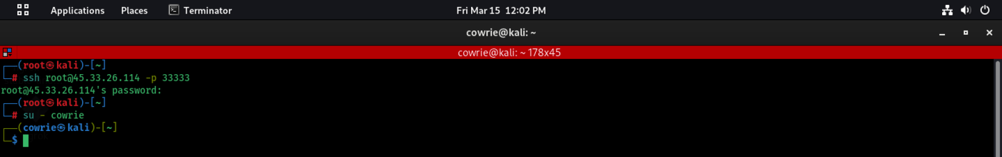

6. **Checked the Log for new connections:**

- Cowrie logs are typically located in /var/log/cowrie/.

- Used the cat command to view the logs:

(cat cowrie.log)

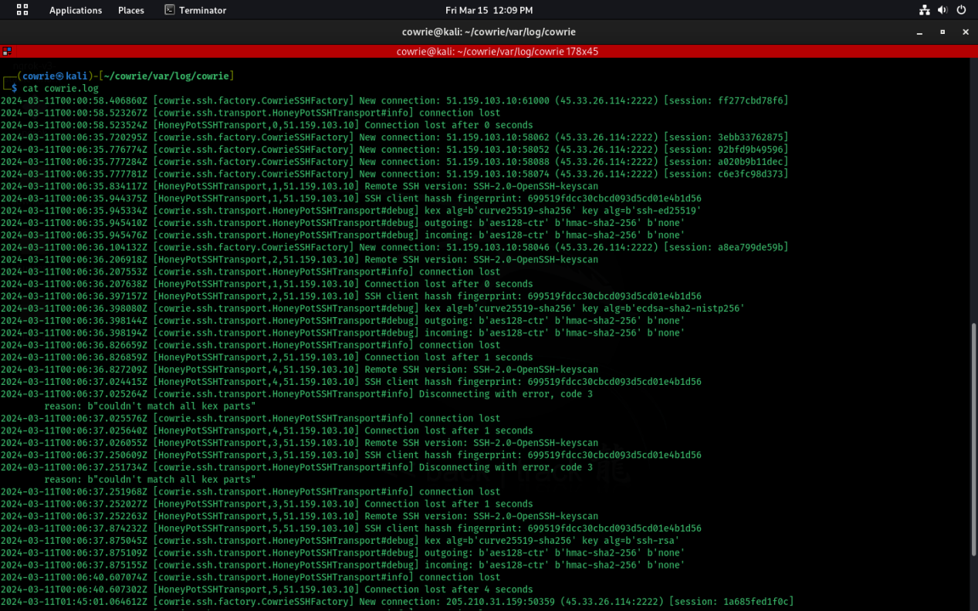

7. **Starting the Cowrie Service:**

- Start the Cowrie service:

service cowrie start